**World Quant University**

**Professor: Harry Wang**

**Algorithms II**

Nikolas Lippmann Pareschi - [nikolaslippmann@gmail.com](mailto:nikolaslippmann@gmail.com)

**Assignment 1: Dynamic Programming**

### Problem:   Longest palindrome subsequence

* Give an efficient algorithm to find the longest palindrome that is a subsequence of a given input string. For example, given the input character, your algorithm should return carac

The main idea of Dynamic Programming is to identify when the optimal solution to a problem is composed of optimal solutions to sub-problems. This is the case in the longest palindrome. Each letter is a palindrome per se. The longest palindrome is the composition of optimal sub paldinromes. In the algorithm below we first create a table to store the results of subproblems. We then loop through the text and check for similarity for every index of the text. We update the palindrome.

Code:

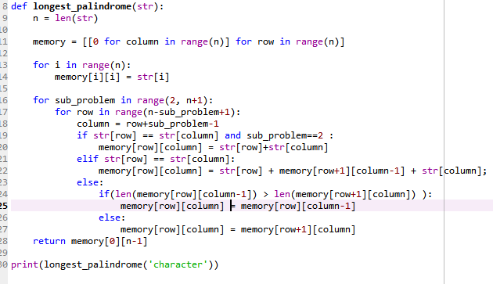

* What is the running time of your algorithm?

The running time of the algorithm is O(2^n). It is possible to span all the Is and Js of our constructed table through the loop.